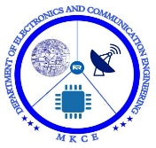 

SHOCKLESS TOUCH AUTOMATION

**MINOR PROJECT I REPORT**

***Submitted by***

|  |  |
| --- | --- |
| **SUJIT M** | **927621BEC221** |
| **SUDHARSUN S** | **927621BEC219** |
| **SRIDHAR R C** | **927621BEC210** |
| **SUBHASH K** | **927621BEC218** |

**BACHELOR OF ENGINEERING**

in

**DEPARTMENT OF ELECTRONICS AND COMMUNICATION ENGINEERING**

**M.KUMARASAMY COLLEGE OF ENGINEERING**

(Autonomous)

**KARUR – 639 113**

**DECEMBER 2022**

**M.KUMARASAMY COLLEGE OF ENGINEERING KARUR**

**BONAFIDE CERTIFICATE**

Certified that this project report “**SHOCKLESS TOUCH AUTOMATION** ” is the bonafide work of “ SUJIT M(927621BEC221), SUDHARSUN S(927621BEC219), SRIDHAR RC(927621BEC210), SUBHASH K(927621BEC218)” who carried out project work under my supervision in the academic year 2022-2023.

|  |  |
| --- | --- |
| **SIGNATURE** | **SIGNATURE** |
| Dr.S.PALANIVELRAJAN, M.E., Ph.D., | Dr. S.VIMALNATH, , M.E., Ph.D., |
| **Professor and Head,** | **Assistant Professor,** |
| Department of Electronics and | Department of Electronics and |
| Communication Engineering, | Communication Engineering, |
| M.Kumarasamy College of Engineering, | M.Kumarasamy College of  Engineering, |
| Thalavapalayam, Karur-639113. | Thalavapalayam, Karur-639113. |

This Minor project-III report has been submitted for the **18ECP105L – Minor Project-I**

Review held at M. Kumarasamy College of Engineering, Karur on

**PROJECT COORDINATOR**

**Vision of the Institution**

To emerge as a leader among the top institutions in the field of technical

education

## **Mission of the Institution**

**M1:** Produce smart technocrats with empirical knowledge who can surmount the global challenges

**M2:** Create a diverse, fully engaged, learner-centric campus environment

to provide quality education to the students

**M3:** Maintain mutually beneficial partnerships with our alumni, industry, and Professional associations Vision of the Department

## **Vision of the Department**

To empower the Electronics and Communication Engineering students with emerging technologies, professionalism, innovative research, and social responsibility.

## **Mission of the Department**

**M1:** Attain the academic excellence through innovative teaching learning process, research areas & laboratories and Consultancy projects. **M2:** Inculcate the students in problem solving and lifelong learning ability.

**M3:** Provide entrepreneurial skills and leadership qualities.

**M4:** Render the technical knowledge and skills of faculty members.

## **Program Educational Objectives (PEOs):**

**PEO1: Core Competence:** Graduates will have a successful career in academia

or industry associated with Electronics and Communication Engineering.

**PEO2: Professionalism:** Graduates will provide feasible solutions for the challenging problems through comprehensive research and innovation in the allied areas of Electronics and Communication Engineering.

**PEO3: Lifelong Learning:** Graduates will contribute to the social needs through lifelong learning, practicing professional ethics and leadership quality

**Program Outcomes (POs):**

**PO 1: Engineering knowledge:** Apply the knowledge of mathematics, science, engineering fundamentals, and an engineering specialization to the solution of complex engineering problems.

**PO 2: Problem analysis:** Identify, formulate, review research literature, and analyze complex engineering problems reaching substantiated conclusions using first principles of mathematics, natural sciences, and engineering sciences.

**PO 3: Design/development of solutions:** Design solutions for complex engineering problems and design system components or processes that meet the specified needs with appropriate consideration for the public health and safety, and the cultural, societal, and environmental considerations.

**PO 4: Conduct investigations of complex problems:** Use research-based knowledge and research methods including design of experiments, analysis and interpretation of data, and synthesis of the information to provide valid conclusions.

**PO 5: Modern tool usage:** Create, select, and apply appropriate techniques, resources, and modern engineering and IT tools including prediction and modeling to complex engineering activities with an understanding of the limitations.

**PO 6: The engineer and society:** Apply reasoning informed by the contextual knowledge to assess societal, health, safety, legal and cultural issues, and the consequent responsibilities relevant to the professional engineering practice.

**PO 7: Environment and sustainability:** Understand the impact of the professional engineering solutions in societal and environmental contexts, and demonstrate the knowledge of, and need for sustainable development.

**PO 8: Ethics:** Apply ethical principles and commit to professional ethics and

responsibilities and norms of the engineering practice.

**PO 9: Individual and teamwork:** Function effectively as an individual, and as a member or leader in diverse teams, and in multidisciplinary settings.

**PO 10: Communication:** Communicate effectively on complex engineering activities with the engineering community and with society at large, such as, being able to comprehend and write effective reports and design documentation, make effective presentations, and give and receive clear instructions.

**PO 11: Project management and finance:** Demonstrate knowledge and understanding of the engineering and management principles and apply these to one’s own work, as a member and leader in a team, to manage projects and in multidisciplinary environments.

**PO 12: Life-long learning:** Recognize the need for and have the preparation and ability to engage in independent and life-long learning in the broadest context of technological change.

## **Program Specific Outcomes (PSOs):**

**PSO1:** Applying knowledge in various areas, like Electronics, Communications, Signal processing, VLSI, Embedded systems etc., in the design and implementation of Engineering application.

**PSO2:** Able to solve complex problems in Electronics and Communication Engineering with analytical and managerial skills either independently or in team using latest hardware and software tools to fulfil the industrial expectations .

.

# TABLE OF CONTENTS

|  |  |  |
| --- | --- | --- |
| **CHAPTER**  **NO.** | **TITLE** | **PAGE NO.** |
|  | **ABSTRACT** | 1 |
|  | **LIST OF FIGURES** | 2 |
|  | **LIST OF ABBREVATIONS** | 2 |
| **1** | **INTRODUCTION** | 3 |
|  | 1.1 Introduction | 3 |
|  | 1.2 Necessity | 4 |
|  | 1.3 Scope of the work | 4 |
| **2** | **SYSTEM MODEL** | 5 |
|  | 2.1 Introduction | 5 |
|  | 2.2 Block Diagram | 5 |
|  | 2.3 Description of Various blocks | 6 |
| **3** | **HARDWARE DESCRIPTION** | 7 |
|  | 3.1 Introduction | 7 |
|  | 3.2 Circuit diagram | 7 |
|  | 3.3 Hardware components | 8 |
| **4** | **RESULT AND DISCUSSION** | 11 |
|  | 4.1 Hardware Implementation | 11 |
|  |  |  |
| **5** | **CONCLUSION AND FUTURE SCOPE** | 12 |
|  | 5.1 Conclusion | 12 |
|  | 5.2 Future Scope | 12 |
|  | 5.3 Applications | 13 |
|  | **REFERENCES** | 14 |

**ABSTRACT**

In recent years, the home environment has project focuses on assisting the users to control as well as to know the exact status of electric appliances in their home at that instant by using GSM and Zig-Bee which is wireless communication. Previously home automation is very complicated based on hardware. Thus, it is difficult to maintain Factors like security, reliability, usefulness, robustness, and price. Now a days it consists of touchscreen which easy to use. Now that human and computer interaction has been developed into a wider and more sophisticated field., designing and operating of intelligence system has been more user friendly than ever. Home automation is a system that helps a user to operate switching various appliances and lighting devices from a single input. The touch screen used as input is much simpler to operate. Touch screen has been widely accepted as the most comfortable input to be provided to the user. Not only they are easy to operate but they also give a sense of personal involvement which the user always appreciates.

# LIST OF FIGURES

|  |  |  |
| --- | --- | --- |
| **Fig.No** | **TITLE** | **PAGE No** |
| 2.1 | Block diagram of the system | 3 |
| 3.1 | Circuit diagram of the system | 5 |
| 4.1 | Experimental Setup | 9 |

**LIST OF ABBREVIATIONS**

|  |  |  |
| --- | --- | --- |
| **S.No** | **ABBREVIATION** | **EXPANSION** |
| 1. | SMPS | Switched Mode Power Supply |
| 2. | SCADA | Supervisory Control and Data Acquisition |
| 3 | PLC | Logic Controller Programmable |

# CHAPTER 1

**INTRODUCTION**

# Introduction

The sense of touch is an important sensory channel in many animals and some plants. Our senses inform to us when our hands touch something. Computer input devices are indifferent to human contact as there is no reaction from software in the event of making, maintaining, or breaking physical contact like touches or releases.

Thus, touch sensing input devices offers numerous possibilities for novel interaction techniques. Touch sensor technology is slowly replacing the mechanical objects like mouse and keyboard.

A touch sensor detects touch or near proximity without relying on physical contact. Touch sensors are making their way into many applications like mobile phones, remote controls, control panels, etc. Present day touch sensors can replace mechanical buttons and switches.

Touch sensors with simple rotational sliders, touch pads and rotary wheels offer significant advantages for more intuitive user interfaces. Touch sensors are more convenient and more reliable to use without moving parts. The use of touch sensors provides great freedom to the system designer and help in reducing the overall cost of the system. The overall look of the system can be more appealing and contemporary

# Necessity

A touch sensor is a type of device that captures and records physical touch or embrace on a device and/or object. It enables a device or object to detect touch or near proximity, typically by a human user or operator. Touch sensing input devices offer numerous possibilities for novel interaction techniques, and it reliably replaces mechanical buttons and switches to eliminate mechanical wear and tear. These can be configured into simple sliders, rotary wheels, or touch pads for intuitive user interfaces.

A touch sensor primarily works when an object or individual gets in physical contact with it. Touch sensors are also called as tactile sensors and are sensitive to touch, force, or pressure. It can be implemented using Capacitive or Resistive sensing technology.

Capacitive sensing is a technology based on capacitive coupling that can detect and measure anything that is conductive or has a dielectric difference from air. Capacitive touch screens distinguish, and sense specific touch location based on the electrical impulses in a human body, typically the fingertip. This enables capacitive touch screens to not require any actual force to be applied to the screen’s surface.

Capacitive touch screen technology is a popular and durable technology that is used in a wide range of applications. Capacitive touchscreens are very clear, offering up to 90 percent transparency. Due to its higher clarity than resistive technology it is used in smartphones.

**1.3 Scope of Work**

Automation is a field that is relevant to all streams of Engineering. It is however closely related to the discipline of Electrical Engineering because the logic that is achieved by the Programmable Logic Controller(PLC) programming today, was first done using Electrical Wiring. If one knows how to get a particular result by wiring the inputs/outputs, then he can easily pick up automation and make a rewarding career in it.

Automation is to control the industrial machinery and process with PLC and SCADA (Supervisory Control and Data Acquisition). It helps reduce the need for human intervention. It plays an increasingly vital role in the global economy and in daily experiences. Automation and control systems enable safe and efficient operation of Industrial plants by minimizing risks.

# CHAPTER-2 SYSTEM MODEL

# Introduction

A touch sensor detects touch or near proximity without relying on physical contact. Touch sensors are making their way into many applications like mobile phones, remote controls, control panels, etc. Present day touch sensors can replace mechanical buttons and switches.

Touch sensors with simple rotational sliders, touch pads and rotary wheels offer significant advantages for more intuitive user interfaces. Touch sensors are more convenient and more reliable to use without moving parts. The use of touch sensors provides great freedom to the system designer and help in reducing the overall cost of the system. The overall look of the system can be more appealing and contemporary.

# 2.2Block Diagram of shockless touch automation

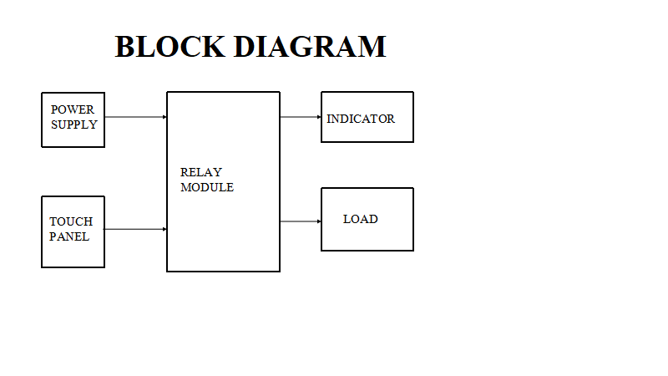

Figure no 2.2.1(Shockless Touch Automation)

**2.3 Description of Various blocks**

**2.3.1 Relay**

Relay is a switch, which opens and closes the circuit electronically. It uses electromagnetism from small voltage to provide higher voltages. It has two basic contacts i.e., NO (Normally Open) and NC (Normally Closed). When input voltage is applied across its coil, NC changes to NO and NO changes to NC. When input voltage is supplied, we say that the relay is energized. It has several features e.g., it can be used for switching smaller voltage to higher. But it cannot be used in power consuming devices. It has a wide range of applications. It can be used in home appliances, electronic circuits where there is a need of protection, robotics for controlling its motors from the proper motion and many more

**2.3.2 Touch Sensor**

A touch sensor detects touch or near proximity without relying on physical contact. Touch sensors are making their way into many applications like mobile phones, remote controls, control panels, etc. Present day touch sensors can replace mechanical buttons and switches.

Touch sensors with simple rotational sliders, touch pads and rotary wheels offer significant advantages for more intuitive user interfaces. Touch sensors are more convenient and more reliable to use without moving parts. The use of touch sensors provides great freedom to the system designer and help in reducing the overall cost of the system. The overall look of the system can be more appealing and contemporary.

**2.3.3 SMPS**

A switched-mode power supply (SMPS) is an electronic circuit that converts power using switching devices that are turned on and off at high frequencies, and storage components such as inductors or capacitors to supply power when the switching device is in its non-conduction state.

Switching power supplies have high efficiency and are widely used in a variety of electronic equipment, including computers and other sensitive equipment requiring stable and efficient power supply.

A switched-mode power supply is also known as a switch-mode power supply or switching-mode power supply.

# CHAPTER 3

**HARDWARE IMPLEMENTATION**

* 1. **Introduction**

Capacitive sensing is a technology based on capacitive coupling that can detect and measure anything that is conductive or has a dielectric difference from air. Capacitive touch screens distinguish, and sense specific touch location based on the electrical impulses in a human body, typically the fingertip. This enables capacitive touch screens to not require any actual force to be applied to the screen’s surface.

# Circuit diagram for shockless touch automation

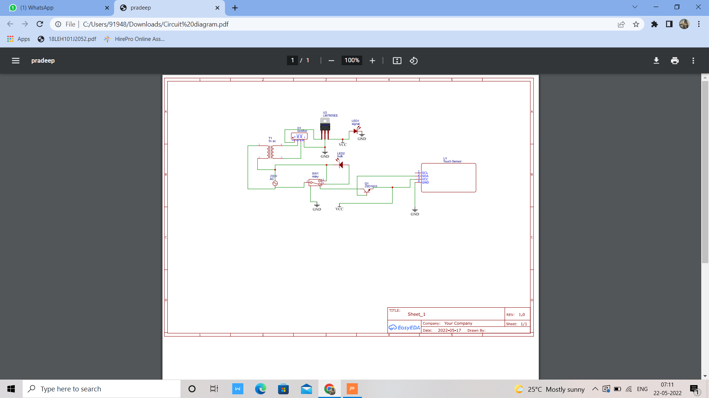

Figure no 3.2.1(shockless touch automation)

* 1. **Hardware Components**
* Relay
* SMPS
* Touch Sensor
* Transistor
* Capacitor

**Components Explanation**

**3.3.1 Relay**

This is called energizing of relay. When the supply is removed it retrieves back to the original position. This is called De energizing of relay. There are also such relays, whose contacts are initially closed and opened when there is supply i.e. exactly to opposite to the above shown relay. Solid state relays will have sensing element to sense the input voltage and switches the output using opto-coupling.

**3.3.2 SMPS**

AC-DC Converter SMPS Working: AC to DC converter SMPS In this type of SMPS, the input supply is AC, and, in the output, we get DC supply. Rectifiers and filters are used to convert this AC power to DC. This uncontrollable DC voltage is given to the affected power factor correction circuits. This is because there is a low current pulse inside the rectifier around the peak of the voltage. This includes high-frequency energy which influences to reduce the power factor. This is due to power conversion, but we have used AC input instead of DC input supply. Therefore, a combination of rectifier and filter, this block diagram is used to convert AC to DC, and switching an operation is done using a power muffle amplifier. MOSFET transistors use low resistance and can resist high currents. The switching frequency is chosen so that normal humans (above 20KHz) must be kept low, and the operation of the switch is controlled using a PWM oscillator.Again this AC voltage is given to the output of the transformer as shown in the figure or the voltage level goes down. After that, the output of this transformer is fixed and smoothed using the Output filter and corrector. The output voltage is controlled by the reaction circuit compared to the reference voltage

1. DC-DC Converter SMPS Working: DC to DC converter SMPS The input supply of this power source is taken from the high voltage DC power directly from the DC power source. This high voltage DC power source is then reduced to 15KHz-5KHz. It is then fed to a 50 Hz step-down transformer unit. The output of this transformer is the input of the rectifier and the output.

**3.3.3 Touch Sensor**

Touch sensors work like a switch. When they are subjected to touch, pressure or force they get activated and acts as a closed switch. When the pressure or contact is removed, they act as an open switch. Capacitive touch sensor contains two parallel conductors with an insulator between them. These conductors’ plates act as a capacitor with a capacitance value C0. When these conductor plates met our fingers, our finger acts as a conductive object. Due to this, there will be an uncertain increase in the capacitance. A capacitance measuring circuit continuously measures the capacitance C0 of the sensor. When this circuit detects a change in capacitance it generates a signal. The resistive touch sensors calculate the pressure applied on the surface to sense the touch. These sensors contain two conductive films coated with indium tin oxide, which is a good conductor of electricity, separated by a very small distance. Across the surface of the films, a constant voltage is applied. When pressure is applied to the top film, it touches the bottom film. This generates a voltage drop which is detected by a controller circuit and signal is generated thereby detecting the touch.

**3.3.4 Transistor**

The element named silicon is generally preferred for transistor construction. The silicon is less sensitive to the temperature. It has the capability of handling the high values of voltages and the greater ranges of currents. As it is known that the emitter base junction must be in forward bias, and the collector base junction remain in reverse bias. Because of the forward bias condition at the emitter base junction there is most of the carriers entered into the base. This is the reason for the constitution of the base current that tends to flow through the region of base. This current tends to flow towards the collector and in response the electron movement is observed in the collector region from base. The base current is also responsible for creation of vacancy at the collector. But it has small magnitude. As we already know that the base present in the transistor has always lightly doped. This is the reason there will be the lesser amount of charge carriers like electrons are less in amount in comparison with that of the emitter. These few amounts of electrons get interacted with respect to the holes at the base whereas the left-over number of electrons can be seen moving towards the collector.

**3.3.5 Capacitor**

A capacitor is an electronic device that is used to store electrical charge. It is one of the most important electronic devices in circuit design. A capacitor is a passive component that can store both negative and positive charges. This is the reason why it can temporarily behave as a battery. Depending upon the design, construction, size, and storage capacity of a capacitor, it can be used in a variety of applications. The property of storing charges associated with the capacitors is known as capacitance. The capacitance is defined as the ratio of electric charges accumulated across the conducting plates of the capacitor and the potential difference existing between them. The capacitance is measured in Farads, which is named after English physicist Michael Faraday.

# CHAPTER 4

**RESULT AND DISCUSSION**

# Hardware Implementation

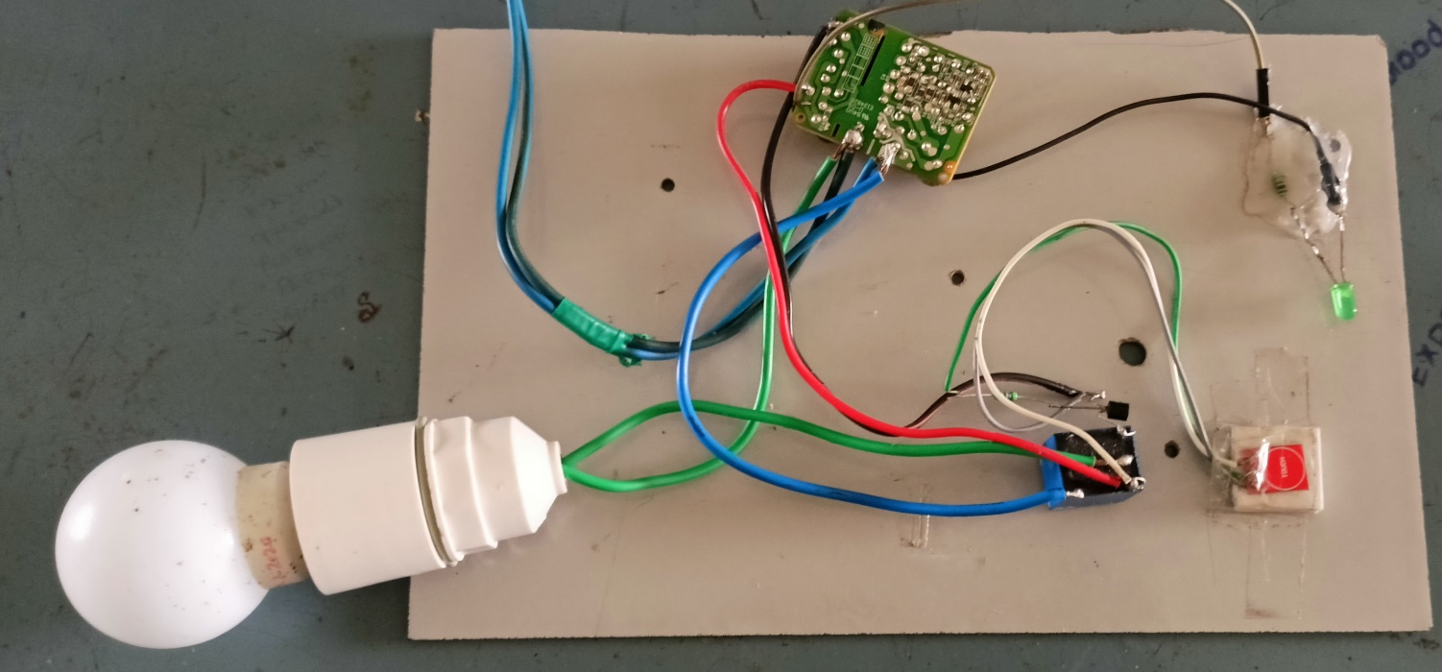

\

Figure no 4.1.1(Hardware implementation)

**CHAPTER 5**

**CONCLUSION AND FUTURE SCOPE**

* 1. **CONCLUSION**

There has been remarkable progress in automation since its envisioning by engineers in the middle of the twentieth century; and it has come with benefits as well as challenges and limitations. Today, automation can perform very complex tasks, resulting in high volumes of quality products at low cost with minimal or no accidents. Its implementation is however encumbered by the high initial cost setting it up. Its progress is also set to economic and technological constraints.

# Future Scope

Automation is not just a word but a requirement of everyone in the future. Technology made it possible to control your home appliances with the help of mobile application or voice assistants.

People in India are quickly adopting this technology but still, this technology is new for most people.

You can set timers or run schedules on your appliances once you have made them smart, like turning on geyser at 7am automatically or turning on balcony lights at 8pm when it is dark every day. These devices will automatically run these commands according to the pre-defined schedules.

This will be a revolution in the future to change simple homes into smart homes to make consumers more comfortable and add convenience to their life. Home automation will even help make your home secure as homeowners will be notified on their phone about any unusual activity in their smart home.

Also, it will help homeowners to recognize who is ringing their home bell from the comfort of their phone. And they can even lock and unlock the door according to their preference.

In short, home automation has a huge scope in the future. Everyone will opt for this technology happily because of the energy saving behavior and more security accessibility features of smart homes

**5.3 Applications**

* Portable devices
* Smartphones and tablets
* Home applications
* Automotives and industrial usages
* Musical instruments, touchpads, etc.
* Older music players, game consoles
* Office equipment

# REFERENCES

1. Groover, Mikell (2014). Fundamentals of M3odern Manufacturing: Materials, Processes, and Systems.
2. Lyshevski, S.E. Electromechanical Systems and Devices 1st Edition. CRC

Press, 2008. ISBN 1420069721.

1. Lamb, Frank. Industrial Automation: Hands On (English Edition). NC,

McGraw-Hill Education, 2013. ISBN 978-0071816458

1. Harris, John (29 December 2016). "The lesson of Trump and Brexit: a society too complex for its people risks everything | John Harris". The Guardian. ISSN 0261-3077.
2. "Feedback and control systems" – JJ Di Steffano, AR Stubberud, IJ Williams. Schaums outline series, McGraw-Hill 1967
3. Guarnieri, M. (2010). "The Roots of Automation Before Mechatronics".

IEEE Ind. Electron. M. 4 (2): 42–43. doi:10.1109/MIE.2010.936772. S2CID

24885437.

1. Donald Routledge Hill, "Mechanical Engineering in the Medieval Near

East", Scientific American, May 1991, pp. 64-69.

1. Musson; Robinson (1969). Science and Technology in the Industrial

Revolution. University of Toronto Press. ISBN 978